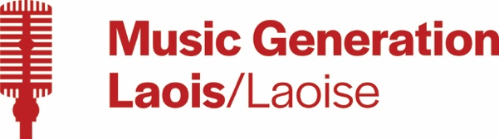

**Music Generation Laois 2024-2025**

**Trad Programme**

**Harp** (age 8 upwards) – 30 minute group lesson - €270 annual fee

**Harp Ensemble** (age 10 upwards) - 1 hour weekly - €150 annual fee

**Trad Flute, Concertina** (age 8 upwards) - 30 minute group lesson - €270 annual fee

**Tin Whistle** (age 7 upwards) – 30 minute group lessons - €270 annual fee

**Bodhrán** (age 8 upwards) – 30 minute group lessons - €270 annual fee

**Uilleann pipes** (age 8 upwards)  – 45 minute group lessons - €405 annual fee

**Junior Trad Group** -  1 hour weekly - €150 annual fee (by audition only)

**Intermediate Trad Group + Trad Orchestra** -  1 hour 30 minutes weekly - €150 annual fee (by audition only)

**Rock & Pop Programme**

**Guitar/Bass/Ukulele** (ukulele age 7 upwards, guitar & bass age 8 upwards) – 30 minute group lesson - €270 annual fee

**Drum kit** (age 8 upwards) 30 minute group lesson - €270 annual fee

**Keyboard** (age 8 upwards) 30 minute group lesson - €270 annual fee

**Singing** (age 8 upwards) 30 minute group lesson - €270 annual fee

**Weekly Jam Time** (age 10 upwards) 1 hour weekly - €150 annual fee

**Orchestral Programme**

**Brass: trumpet, trombone, euphonium, tuba** (age 8 upwards) 30 minute group lesson - €270 annual fee

**Oboe, Double Bass** (age 8 upwards) 30 minute group lessons - €270 annual fee

**World Music Programme**

**Handpan** (age 8 upwards) 30 minute group lessons - €270 annual fee

**The Music Box**

**The Music Box** Programme for Young People with Special Needs (Age 4 upwards) 30 minute individual classes - €750 annual fee

Please note all programmes are 30 weeks except Jam Time, Ensembles, Trad Groups and Orchestras.

Jam Time, Ensembles, Trad Groups and Orchestras vary to account for performances throughout the year.

Musical instruments are available for hire.

A €50 deposit is payable to secure your space in a class.

**How to get involved:**

Click on the ‘Sign Up Form’ on our website musicgenerationlaois.ie

If you request to sign-up to a specific instrument, and you meet the age criteria to join the requested class, we will reply back with an offer of a class if we have availability.

If we do not have availability we will add you to our waiting list and we will contact you by email when/if a space becomes available.